
CSA15 – CLOUD COMPUTING AND BIG DATA ANALYTICS

ASSIGNMENT 1 – CO1
Design, Analyse and Validate a Cloud-Based Solution for Migrating a Legacy University Management System
CO1: Apply cloud computing technologies including hardware–software evolution, virtualization, web services, and service models to develop cloud-based solutions.

Field | Details | Field | Details
Student Name | Mohamed saif A | Register Number | 192521171
Department / Section | IT | Academic Year / Semester | 2025
Faculty Name | Dr latha R | Nature of Assignment | Individual
Duration | 1 Week | Total Marks | 50
Submission Date |  | Evaluation Date

MARK SHEET (Rubric-based evaluation)
Task | Title | Max | Awarded | Evidence / evaluation focus
1 | Introduce Cloud Computing | 3 |  | Definition; characteristics; deployment models; scenario mapping
2 | Trace Evolution and Hardware Evolution | 3 |  | Timeline; hardware evolution; relevance to university
3 | Analyse Internet Software Evolution | 3 |  | Web/software evolution; SOA; APIs; scenario relevance
4 | Apply Server Virtualization | 5 |  | Hypervisor types; VM/container comparison; consolidation; limitations
5 | Apply Web Services | 4 |  | SOA and SOAP/REST; three university APIs; request/response examples
6 | Analyse IaaS, PaaS and SaaS | 5 |  | Responsibility layers; five-application mapping; comparison; providers
7 | Examine XaaS | 3 |  | Four or more variants; two justified choices; provider risks
8 | Design Cloud Solution Architecture | 5 |  | Labelled diagram; deployment/service models; scaling; security; DR
9 | Hands-on Implementation and Documentation | 4 |  | Running VM/container; PaaS/SaaS; tests; actual screenshots
10 | Evaluate and Recommend Final Solution | 7 |  | Three-way comparison; 3-year costs; risks; phased roadmap
11 | Day-4 Design Challenge | 8 |  | Impact; evaluation; adaptation; evidence-based defence
 | TOTAL | 50 |  | Percentage :

EVIDENCE VERIFICATION CHECKLIST

Tasks | Evidence expected | Status (✓ / P / ✗) | Evaluator note
1–3 | Conceptual explanations, comparisons and relevant illustrations | ✓ | Explanations and relevant scenario mapping documented
4 | Virtualization calculations with stated assumptions and peak-load caution | ✓ | Calculations present; practical capacity validation recommended
5–7 | API examples, service responsibility table and justified XaaS choices | ✓ | Required conceptual evidence documented
8 | Labelled architecture diagram, caption below figure and component justification | ✓ | Architecture documented; sizing assumptions need testing
9 | Actual code, environment details, execution logs, API outputs and screenshots | P | Procedures provided; actual execution evidence not established
10 | Cost assumptions, 3-year totals, risk controls and migration roadmap | ✓ | Estimates and rationale documented
11 | Day-4 changes, 10× load strategy, 99.9% target and 40-college isolation | ✓ | Design analysis documented; practical validation pending

IMPLEMENTATION EVIDENCE CHAIN

Evidence item | Status | Observation
Source code | ✓ | Flask REST API and Dockerfile provided in the proposed implementation
Virtualization | P | Docker container configuration documented; running-container evidence required
PaaS or SaaS | P | Managed web-service deployment procedure described; live deployment not verified
Functional test | P | Expected HTTP 200 response and JSON output documented; actual output required
Failure case | P | HTTP 404 test case documented; actual execution record required
Screenshots | P | Screenshot requirements identified; authentic screenshots need verification
Reproducibility | ✓ | Build commands, run commands, endpoints and expected results specified

OVERALL REMARKS

_______________  Student Signature | _______________  Faculty Signature | _______________  Program Director
MANDATORY SUBMISSION EVIDENCE CHECK
✓ = Present in documented answer; P = Partly present; ✗ = Missing / not satisfied
Task | Evidence expected | Status | Evaluator note
1 | Cloud definition, characteristics, deployment models and scenario mapping | ✓ | All conceptual requirements covered
2 | Evolution timeline, hardware development and university relevance | ✓ | Well explained with relevant examples
3 | Internet software evolution, SOA and APIs | ✓ | Clear explanation and scenario relevance
4 | Hypervisors, VM/container comparison and consolidation calculations | ✓ | Calculations included; peak-load limitations discussed
5 | SOAP/REST comparison and three university APIs | ✓ | API methods and request/response examples documented
6 | IaaS/PaaS/SaaS responsibility layers and application mapping | ✓ | All five applications categorized with justification
7 | XaaS variants and two justified selections | ✓ | Six variants explained; DBaaS and DRaaS recommended
8 | Labelled architecture, scaling, security and disaster recovery | ✓ | Design and component justifications documented
9 | Working container, PaaS/SaaS deployment, actual tests and screenshots | P | Code and procedures provided; actual execution evidence requires verification
10 | Three-year cost comparison, risks and migration roadmap | ✓ | Cost assumptions, calculations and recommendations included
11 | Impact analysis, 10× load, 99.9% availability and tenant isolation | ✓ | Changed requirements evaluated; load-test evidence recommended

IMPLEMENTATION EVIDENCE CHAIN
Evidence item | Status | Observation
Source code | ✓ | Python Flask REST API and Dockerfile documented
Virtualization | P | Docker build and run procedures provided; execution screenshot required
PaaS or SaaS | P | Cloud deployment steps described; actual deployment confirmation required
Functional test | P | HTTP 200 and expected JSON response documented; actual test output required
Failure case | P | HTTP 404 test case included; execution evidence required
Screenshots | P | Required screenshots identified but authenticity and completeness not verified
Reproducibility | ✓ | Installation, configuration, commands and testing steps documented
Interpretation | ✓ | Technical outcomes and implementation limitations explained
Code and report consistency | ✓ | Proposed API, Docker configuration and testing procedure are aligned

SUBMISSION CHECKLIST (Not Separately Marked)
Requirement | Status
All 11 tasks answered | ☒ Yes ☐ Partly ☐ No
Cloud concepts and comparisons explained | ☒ Yes ☐ Partly ☐ No
Virtualization calculations included | ☒ Yes ☐ Partly ☐ No
API examples and service models explained | ☒ Yes ☐ Partly ☐ No
Cloud architecture diagram included | ☒ Yes ☐ Partly ☐ No
Implementation and testing evidence provided | ☐ Yes ☒ Partly ☐ No
Three-year cost analysis and roadmap included | ☒ Yes ☐ Partly ☐ No
Day-4 design challenge completed | ☒ Yes ☐ Partly ☐ No
Figures and screenshots included | ☐ Yes ☒ Partly ☐ No
Table and figure numbering correct | ☐ Yes ☒ Partly ☐ No
Viva recommended | ☒ Yes ☐ No

CSA15 – Cloud Computing and Big Data Analytics
ASSIGNMENT 1
CO1: Apply cloud computing technologies including hardware–software evolution, virtualization, web services, and service models to develop cloud-based solutions.

Assignment Title: Design, Analyse and Validate a Cloud-Based Solution for Migrating a Legacy University Management System (Total Marks – 50)
Duration: 1 week
Scenario – Smart Campus Cloud Migration
A multi-campus university currently runs its Student Information System, Learning Management System, Library System, Exam Portal and Email on ageing physical servers in a single on-premise data centre. Each application has its own dedicated server, which stays idle for most of the year but fails to cope during admissions, result publication and online-exam weeks.
The university's current environment is:
- 12 physical servers, average CPU utilisation of about 15%, with peaks above 95% during admissions and exams
- Approximately 25,000 students and 2,000 staff across 4 campuses
- Applications built as large monolithic programs, with no public interfaces for mobile apps or partner colleges
- High capital expenditure, slow procurement (6–8 weeks per server) and no disaster recovery site
As a cloud consultant, you must study how computing evolved to the cloud model, and then design a cloud-based solution that uses virtualization, web services and an appropriate mix of service models (IaaS, PaaS, SaaS and XaaS) for the university. All recommendations must be justified in terms of cost, scalability, availability and manageability.
Design Challenge:
On Day 4, the university announces that it will launch a mobile app and open student-record and fee-payment services to 40 affiliated colleges. Expected load is 10 times the current peak, with a requirement of 99.9% availability and a limited operating budget. Re-evaluate your original design and decide whether it should be retained, modified or redesigned.
TASK 1 – Introduce Cloud Computing and Map It to the Scenario (3 Marks)
Design and Propose cloud computing model for the context of the university's problems.
- Definition of cloud computing and the five essential characteristics (on-demand self-service, broad network access, resource pooling, rapid elasticity, measured service)
- Deployment models (public, private, hybrid, community) and which one suits the university
- Three problems of the current on-premise setup and how each cloud characteristic addresses them
- Benefits and limitations of cloud adoption for the university
Evidence Expected
A clear explanation of cloud characteristics and deployment models, mapped to the university's actual problems.
TASK 2 – Trace the Evolution and Hardware Evolution (3 Marks)
Trace how computing infrastructure evolved to make cloud computing possible.
- A timeline from mainframes, minicomputers and PCs, to client–server, clusters, grid computing, utility computing and cloud
- Hardware evolution: multi-core processors, commodity servers, high-capacity storage, high-speed networking and data centres
- How each stage solved a limitation of the previous one
- Which stage the university's current system corresponds to, with reasons
Evidence Expected
A labelled timeline or diagram, with a justified explanation of how hardware advances enabled the cloud.
TASK 3 – Analyse Internet Software Evolution (3 Marks)
Explain how internet software evolved and why it supports cloud services.
- Evolution from static web pages to dynamic web, Web 2.0, SOA, mashups and cloud-hosted applications
- Role of browsers, HTTP, AJAX and APIs in delivering software over the internet
- Comparison between desktop software, client–server software and web-delivered software
- How this evolution affects the design of the university's applications
Evidence Expected
A comparative explanation of software evolution stages, linked to the university's application design.
TASK 4 – Apply Server Virtualization (5 Marks)
Apply server virtualization to consolidate the university's 12 physical servers.
- Explain how a hypervisor works, and distinguish Type-1 and Type-2 hypervisors, with examples
- Compare full virtualization, para-virtualization, OS-level virtualization (containers) and hardware-assisted virtualization
- Propose which applications should run as virtual machines and which as containers, with reasons
- Calculate the consolidation: with an average utilisation of 15% per server and a target host utilisation of 70%, estimate how many physical hosts are needed (show your assumptions and working)
- Discuss live migration, snapshots and resource over-commitment as benefits, and the risks of virtualization (noisy neighbour, hypervisor failure, security isolation)
Show your calculation. A final number without working will not receive full credit.
Evidence Expected
A justified virtualization plan with a worked consolidation calculation and discussion of benefits and risks.
TASK 5 – Apply Web Services (4 Marks)
Analyse web services to expose the university's functions to other systems.
- Overview of web services and their role in cloud and SOA
- Compare SOAP, WSDL, UDDI and RESTful services (HTTP methods, JSON/XML)
- Identify at least three university functions to expose as web services (for example, result lookup, fee payment, library search) and define the endpoint, method and sample request/response for each
- Justify whether SOAP or REST is more suitable for each function
Evidence Expected
A defined set of web services with sample request/response formats and a justified choice of SOAP or REST
TASK 6 – Analyse the Service Models: IaaS, PaaS and SaaS (5 Marks)
Analyse which service model fits each university application.
- Define IaaS, PaaS and SaaS, and show who manages which layer (hardware to application) in each model
- Categorise the five university applications (SIS, LMS, Library, Exam Portal, Email) into IaaS, PaaS or SaaS, with reasons
- Compare the models on control, cost, scalability, maintenance effort and vendor lock-in
- Give one real provider example for each model
Present your categorisation in a table, but explain the reasoning behind each decision. A table alone is not sufficient.
Evidence Expected
A reasoned mapping of applications to service models, supported by a layer-wise responsibility comparison.
TASK 7 – Examine XaaS (3 Marks)
Examine the broader XaaS (Anything-as-a-Service) concept for the university.
- Explain XaaS and describe at least four variants (for example DaaS, BaaS/MBaaS, FaaS, DBaaS, Security-as-a-Service, Disaster-Recovery-as-a-Service)
- Select two XaaS offerings that would benefit the university, and justify them
- Discuss the risks of over-reliance on multiple 'as-a-Service' providers
Evidence Expected
An analysis of XaaS variants, with justified selection of two offerings for the university.
TASK 8 – Design the Cloud Solution Architecture (5 Marks)
Bloom's Level: Level 6 – Create | Action verbs: Design, Construct, Propose
Create a complete cloud architecture for the university by combining virtualization, web services and service models.
- An architecture diagram showing users, load balancer, web/application tier, database tier, storage, API layer and DR region
- The deployment model and the service model chosen for each component
- How elasticity (auto-scaling) will handle admissions and exam peaks
- Basic security and availability measures (access control, encryption, backup, multi-zone deployment)
Evidence Expected
A labelled architecture diagram with written justification for each component and design decision.
TASK 9 – Hands-on Implementation and Documentation (4 Marks)
Implement a small proof-of-concept of your design using a free-tier cloud account or a local virtualization tool.
- Create a virtual machine or container (using AWS/Azure/GCP free tier, VirtualBox, or Docker) and host a simple web page or REST API for one university function
- Deploy a SaaS or PaaS component (for example a cloud-hosted database, a serverless function or a static site)
- Test the web service with a client (browser, Postman or curl) and record the output
- Provide screenshots, configuration steps and any issues faced
Evidence Expected
Annotated screenshots and clear, reproducible steps showing that the proof-of-concept works.
TASK 10 – Evaluate and Recommend the Final Solution (7 Marks)
Evaluate your design and recommend the final cloud solution for the university.
- Compare on-premise, IaaS-based and PaaS/SaaS-based options on cost (CapEx vs OpEx), scalability, availability, security and effort
- Estimate a simple 3-year cost comparison using stated assumptions
- Identify the main risks (vendor lock-in, data privacy, downtime, skills gap) and give mitigation steps
- Provide your final recommendation and a short migration roadmap (which application moves first, and why)
Your recommendation must be supported by the analysis in the previous tasks. Choosing a popular cloud provider without justification is not sufficient.
Evidence Expected
A technically justified recommendation, supported by a cost comparison, risk analysis and migration roadmap.
DAY-4 DESIGN CHALLENGE
TASK 11 – Re-evaluate and Adapt the Design (8 Marks)
Changed Requirement
The university will now launch a mobile app and open student-record and fee-payment services to 40 affiliated colleges. Expected load is 10 times the current peak, availability must be 99.9%, and the operating budget is limited.
Re-evaluate your original design in response to these changed conditions. You may:
RETAIN → MODIFY → or REDESIGN
your original solution.
Impact Analysis – 2 Marks
Discuss:
- What has changed from the original problem
- Which original assumptions (load, users, availability, cost) are affected
- Why the web services and APIs now become critical
- How multi-tenant access by 40 colleges affects security and isolation
Evidence Expected: A clear analysis of how the changed requirements affect the original cloud design.
Evaluation of the Original Design – 2 Marks
Discuss:
- Whether the chosen service models and virtualization plan can handle a 10x load
- Whether auto-scaling and the single-region deployment are sufficient for 99.9% availability (about 8.76 hours of downtime allowed per year)
- Whether cost remains acceptable under the new load
- Whether another service model or XaaS offering would give better overall results
Evidence Expected: A technically supported evaluation of the original design under the new conditions.
Adaptation or Redesign – 2 Marks
Discuss:
- Decide whether to retain, modify or redesign the solution
- Describe the revised architecture (for example API gateway, container orchestration, serverless components, multi-zone deployment or a hybrid model)
- Explain what changed in the service model mix and in the virtualization approach
- If you retain the original design, give sufficient technical justification for why no change is required
Evidence Expected: An appropriate design response to the changed requirement, with clear technical reasoning.
Evidence-Based Defence – 2 Marks
Discuss:
- Capacity and availability calculations
- Cost comparison between the original and the revised design
- Security and multi-tenancy considerations
- Trade-offs such as vendor lock-in, complexity and migration effort
Evidence Expected: A well-supported final decision that follows logically from the analysis.
MARK DISTRIBUTION
Task | Title | Bloom's Level | Marks
Task 1 | Cloud Computing – Introduction & Characteristics | L2 – Understand | 3
Task 2 | Evolution & Hardware Evolution | L2 – Understand | 3
Task 3 | Internet Software Evolution | L2 – Understand | 3
Task 4 | Server Virtualization | L3 – Apply | 5
Task 5 | Web Services | L3 – Apply | 4
Task 6 | Service Models: IaaS, PaaS, SaaS | L4 – Analyze | 5
Task 7 | XaaS | L4 – Analyze | 3
Task 8 | Design the Cloud Solution Architecture | L6 – Create | 5
Task 9 | Hands-on Implementation & Documentation | L3 – Apply | 4
Task 10 | Evaluate & Recommend the Final Solution | L5 – Evaluate | 7
 | Subtotal

Task 11 | Day-4 Design Challenge | L4 / L5 / L6 | 8
 | TOTAL |  | 50

ANSWERS – CSA15 CLOUD COMPUTING AND BIG DATA ANALYTICS (ASSIGNMENT 1 – CO1)
Student: Mohamed Saif A Register Number: 192521171
Assignment: Design, Analyse and Validate a Cloud-Based Solution for Migrating a Legacy University Management System (Smart Campus Cloud Migration)
Approach. The answers below follow the order of the eleven tasks. Every recommendation is tied to the four criteria named in the scenario – cost, scalability, availability and manageability – and to the university's actual figures: 12 physical servers at about 15% average CPU, peaks above 95%, about 27,000 users (25,000 students + 2,000 staff) on 4 campuses, no disaster-recovery (DR) site, and 6–8 weeks to buy a server. Cost figures are stated estimates built on written assumptions (in Indian rupees, ₹ lakh = ₹100,000); they must be re-priced against a real provider quotation before approval.

TASK 1 – Introduce Cloud Computing and Map It to the Scenario (3 Marks)

1.1 Definition of cloud computing
Cloud computing is a model in which computing resources – servers, storage, networks, platforms and applications – are held in a shared pool by a provider and delivered over a network on demand. The customer can obtain or release them quickly, with very little management effort, and pays according to use. The central idea is that capacity becomes a service that is rented, rather than a product that is bought and installed.

1.2 The five essential characteristics, mapped to the university
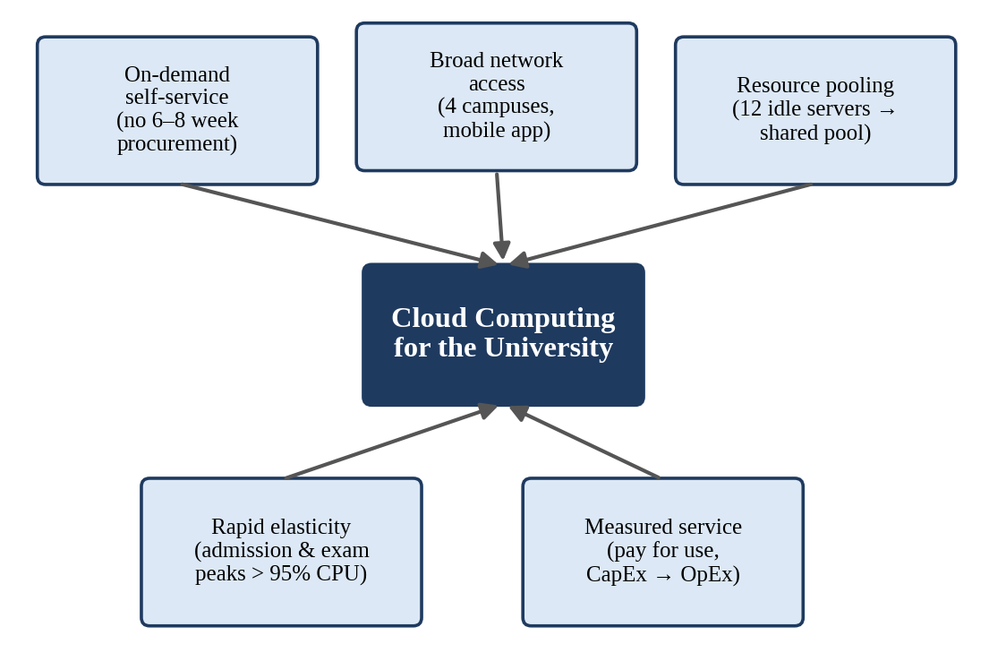
Figure 1: The five essential cloud characteristics mapped to the university's problems.
Table 1: Five essential characteristics of cloud computing and their relevance.
Characteristic | Meaning | University problem it addresses
On-demand self-service | Staff provision servers or storage from a portal without contacting the provider. | Removes the 6–8 week wait to procure a server; a new VM is ready in minutes.
Broad network access | Services are reachable over standard networks from phones, laptops and tablets. | The monolithic applications have no public interface; cloud APIs let the mobile app, 4 campuses and partner colleges connect.
Resource pooling | The provider's resources serve many customers through multi-tenancy; capacity is assigned dynamically. | 12 servers sit at ~15% utilisation because each is dedicated to one application; pooled capacity lets idle resources be shared.
Rapid elasticity | Capacity scales out and in automatically, often within minutes. | CPU exceeds 95% during admissions, results and exam weeks; auto-scaling adds instances for the peak and removes them afterwards.
Measured service | Usage is metered and billed per unit (hour, GB, request). | Replaces high capital expenditure with pay-per-use spending; each department's consumption becomes visible.

1.3 Deployment models and the one that suits the university
Table 2: Cloud deployment models compared for the university.
Model | Description | Fit for the university
Public cloud | Infrastructure owned by a provider and shared by many customers over the internet. | Best for elastic, internet-facing workloads (exam portal, mobile APIs, email); lowest cost, no hardware to buy.
Private cloud | Dedicated cloud environment for one organisation, on-premise or hosted. | Maximum control, but the university would again pay for peak hardware and run it with its own staff.
Hybrid cloud | Public and private/on-premise parts connected so workloads and data can move between them. | Allows sensitive or legacy components to stay local during migration while bursting to public cloud.
Community cloud | Infrastructure shared by organisations with common needs (e.g., a university consortium). | Not needed at first, but becomes attractive on Day 4 when 40 affiliated colleges share student-record and fee services.

Recommendation – a hybrid cloud, mainly public. Elastic and internet-facing applications move to a public cloud, which removes the idle-capacity cost and handles peaks. During migration, the legacy student-master database remains on-premise and is linked by a VPN; it moves later once data-protection and testing requirements are met. This reduces risk on the most sensitive data without delaying the benefits. A community-cloud arrangement for the affiliated colleges can be considered later (Task 11).

1.4 Three current problems and how the cloud characteristics solve them
Table 3: Mapping of the three problems to cloud characteristics.
Current problem | Cause in the on-premise set-up | Characteristic(s) that solve it
1. Wasted capacity and failure at peaks | One dedicated server per application: ~15% average use, >95% at peaks. | Resource pooling + rapid elasticity: shared capacity grows for admissions/exams and shrinks afterwards.
2. High CapEx and slow procurement | Hardware is bought up-front; each server takes 6–8 weeks. | On-demand self-service + measured service: instant provisioning and pay-per-use OpEx.
3. No DR site and no external access | A single data centre; monolithic applications without interfaces. | Broad network access + pooled multi-region infrastructure: replicated DR region and API-based access for mobile and partner colleges.

1.5 Benefits and limitations
• Benefits: lower upfront cost (CapEx → OpEx); capacity matched to demand; built-in DR options; faster delivery of new services (days, not weeks); less hardware administration; access from all campuses and mobile devices.
• Limitations: dependence on internet connectivity; vendor lock-in; data-privacy and legal duties for student records (data residency, India's Digital Personal Data Protection Act); possible cost overruns if usage is unmanaged; the existing staff need new skills; migration of legacy monolithic applications needs effort and testing.

TASK 2 – Trace the Evolution and Hardware Evolution (3 Marks)

2.1 Timeline of computing infrastructure
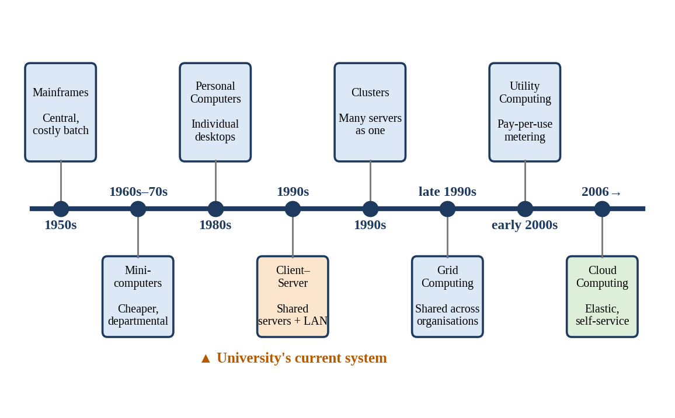
Figure 2: Timeline from mainframes to cloud computing; the university's current system sits at the client–server stage.
Table 4: How each stage solved a limitation of the one before it.
Stage | Typical period | Limitation of the previous stage that it solved
Mainframes | 1950s–60s | Started centralised computing, but very expensive, single location, batch processing.
Minicomputers | 1960s–70s | Cheaper than mainframes, so departments could own computers; still isolated and limited in power.
Personal computers | 1980s | Put computing on every desk and made it interactive; but data and software were scattered and unshared.
Client–server | 1990s | Connected PCs to shared servers over a LAN, giving central data and multi-user applications; servers remained one-per-application and costly to scale.
Clusters | 1990s | Joined many cheap servers to behave as one, giving more power and fault tolerance than a single machine.
Grid computing | Late 1990s–2000s | Shared clusters across organisations for very large tasks; complex, with no simple pay-for-use model.
Utility computing | Early 2000s | Introduced metered, pay-per-use delivery of computing like electricity, but lacked easy self-service and elasticity.
Cloud computing | 2006 onwards | Combined virtualization, web services, self-service and elasticity; resources became instantly available and billed by use (e.g., Amazon EC2 launched in 2006).

2.2 Hardware evolution that made the cloud possible
• Multi-core processors and hardware virtualization support (Intel VT-x, AMD-V): many cores per chip let several virtual machines run at near-native speed.
• Commodity servers: cheap standard x86 servers, replaced when they fail, instead of costly proprietary machines – this makes very large pools economical.
• High-capacity, low-cost storage: large disks and SSDs and distributed storage allow huge, replicated data stores.
• High-speed networking: gigabit and 10/40/100 Gb Ethernet and broadband make remote resources feel local.
• Modern data centres: efficient power and cooling, automation and large scale give providers economies that a single university cannot match.

2.3 Where the university's current system sits
The current environment corresponds to the client–server stage (with the first signs of the clusters stage absent). Reasons: (i) every application has its own dedicated physical server; (ii) the servers are in one data centre with no resource sharing between them, no virtualization and no pooling – hence ~15% utilisation; (iii) capacity is fixed and bought in advance, so peaks above 95% cannot be absorbed; (iv) resources are not metered or self-service; and (v) there is no multi-site resilience. It therefore lacks the characteristics that define the cloud stage, which is why the migration is justified.

TASK 3 – Analyse Internet Software Evolution (3 Marks)

3.1 Evolution of internet software
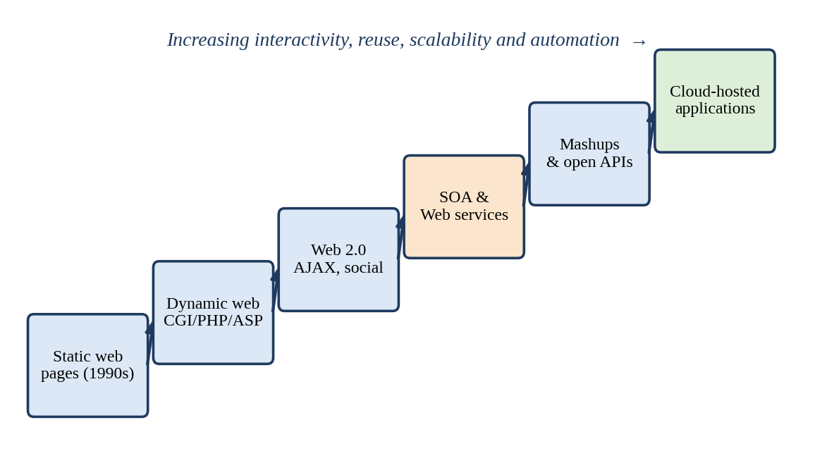
Figure 3: Evolution of internet software from static pages to cloud-hosted applications.
• Static web pages: fixed HTML documents; no user interaction or processing.
• Dynamic web: server-side scripts (CGI, PHP, ASP, JSP) generate pages from databases, enabling online forms and results lookup.
• Web 2.0: interactive, user-driven sites using AJAX, so parts of a page update without reloading; social and collaborative features.
• Service-oriented architecture (SOA) and web services: business functions are exposed as reusable, network-accessible services with standard interfaces.
• Mashups and open APIs: new applications combine services from several providers (e.g., a map plus a fee-payment API).
• Cloud-hosted applications: applications and their data run on provider infrastructure and are delivered as services (SaaS) to browsers and mobile apps.

3.2 Role of browsers, HTTP, AJAX and APIs
• Browser: a universal, installation-free client that renders interfaces and runs JavaScript.
• HTTP/HTTPS: the standard, firewall-friendly protocol that carries requests and responses; HTTPS adds encryption.
• AJAX: asynchronous requests from JavaScript refresh only part of a page, giving a responsive, desktop-like experience over the internet.
• APIs: well-defined interfaces (usually REST/JSON or SOAP/XML) that allow different programs – the mobile app, partner colleges, other cloud services – to use the same functions.

3.3 Desktop, client–server and web-delivered software
Table 5: Comparison of three software delivery styles.
Aspect | Desktop software | Client–server software | Web-delivered (cloud) software
Where it runs | Entirely on the user's computer | Client on the PC; logic/data on a server | In the browser/app; logic and data on cloud servers
Installation and updates | Install and patch on every PC | Client installed and updated per PC; server managed centrally | None or minimal; update once on the server
Data sharing | Poor; local files | Good within the LAN | Good from anywhere with internet
Scalability | None (single user) | Limited by the fixed server | High; elastic back-end
Access | One device | Mostly on campus network | Any device, any campus, mobile
Cost model | Per-licence purchase | Servers + licences (CapEx) | Subscription/usage (OpEx)

3.4 Effect on the design of the university's applications
The university's applications are large monolithic programs with no public interfaces. The software evolution above shows what they must become to benefit from the cloud:
• Decompose the monolith into functional services (student record, results, fees, library search, authentication) that can be scaled and updated independently.
• Expose APIs first: every service gets a REST interface so the mobile app, web portal and partner colleges use the same logic (see Task 5).
• Browser/mobile front ends replace desktop clients, so there is nothing to install on 27,000 user devices.
• Stateless application tier: keep session data in a shared cache/database so any instance can serve any request, which allows auto-scaling.
• Standard protocols and loosely coupled components reduce vendor lock-in and make phased migration possible – moving one service at a time.

TASK 4 – Apply Server Virtualization (5 Marks)

4.1 How a hypervisor works; Type-1 and Type-2
A hypervisor (virtual machine monitor) is software that sits between the physical hardware and the operating systems. It divides the host's CPU, memory, storage and network into several isolated virtual machines (VMs). Each VM has its own guest operating system and believes it has a dedicated computer. The hypervisor schedules CPU time, maps virtual memory and virtual disks to physical ones, and traps privileged instructions so that VMs cannot interfere with one another.
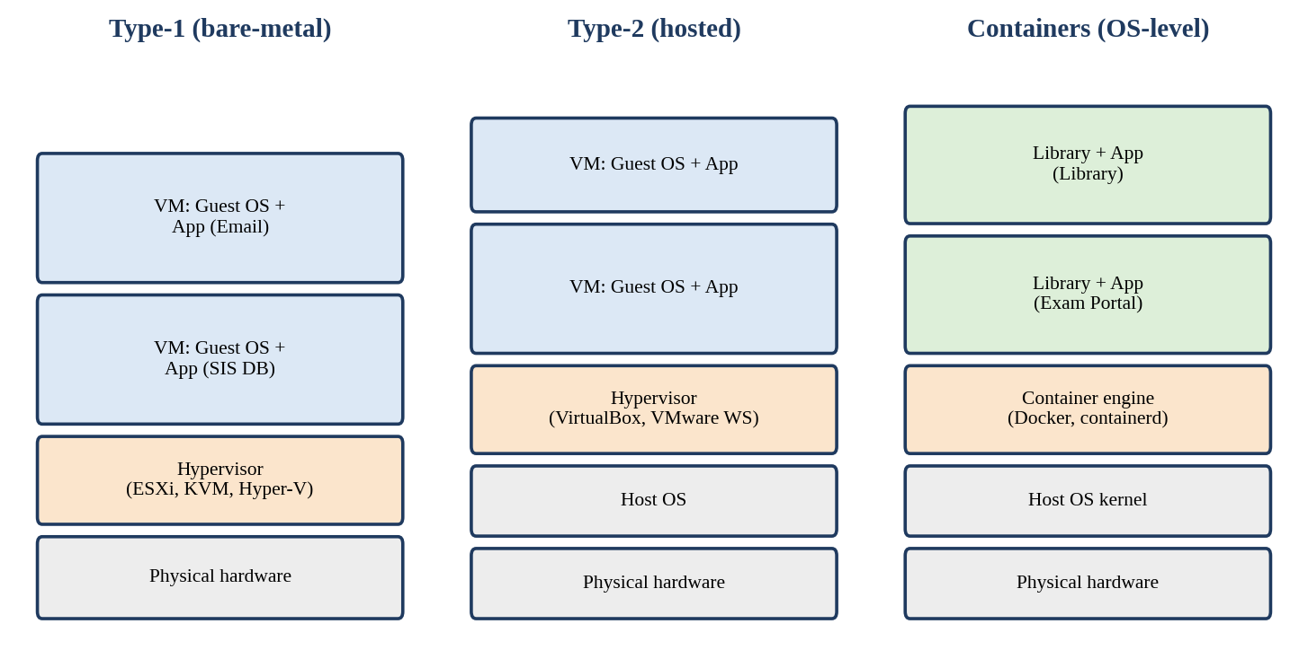
Figure 4: Type-1 hypervisor, Type-2 hypervisor and container architecture.
Table 6: Type-1 versus Type-2 hypervisors.
Feature | Type-1 (bare-metal) | Type-2 (hosted)
Runs on | Directly on the hardware | On top of a host operating system
Performance | High; minimal overhead | Lower; extra OS layer
Typical use | Production data centres and clouds | Developer desktops, testing, training labs
Examples | VMware ESXi, Microsoft Hyper-V, KVM, Xen | Oracle VirtualBox, VMware Workstation, Parallels

4.2 Virtualization techniques compared
Table 7: Comparison of virtualization techniques.
Technique | How it works | Advantages | Disadvantages
Full virtualization | Hypervisor fully emulates the hardware; guest OS runs unmodified (binary translation or hardware assist). | Runs any OS; strong isolation. | Some overhead, especially without hardware support.
Para-virtualization | Guest OS is modified to make hypercalls to the hypervisor instead of privileged instructions. | Better performance than software-emulated full virtualization. | Needs a modified guest kernel; limited OS choice.
OS-level virtualization (containers) | Containers share the host kernel but have isolated processes, file systems and networks. | Very light, start in seconds, high density, ideal for microservices. | Same kernel for all; weaker isolation than VMs; Linux containers need Linux kernel.
Hardware-assisted virtualization | CPU extensions (Intel VT-x, AMD-V, plus EPT/NPT) execute guest code directly and handle privileged operations. | Near-native speed; simpler hypervisors; enables full virtualization of unmodified OSes. | Requires supporting CPUs and enabling in BIOS.

4.3 VMs or containers for the university applications
Table 8: Placement of applications as VMs or containers.
Application | Choice | Reason
Student Information System (SIS) | Database in a VM; web/application tier in containers | The database is stateful and needs strong isolation and predictable I/O; the application tier is stateless and scales as containers.
Learning Management System (LMS) | Containers (web) + managed database/VM | Web tier scales with class timings; plugins and PHP/Python stacks are packaged easily in images.
Library system | Container | Light workload with modest and steady load; a container wastes the least resources.
Exam Portal | Containers with auto-scaling (VMs as nodes) | Highly bursty (peak > 95%); containers start in seconds so capacity follows the exam schedule.
Email server | VM (or SaaS later) | Legacy, stateful, has its own OS-level dependencies and large mailbox storage; a VM keeps it isolated and is easy to snapshot and migrate.

4.4 Consolidation calculation
Assumptions: (1) the 12 existing servers have equal capacity; one server = 1 “server-unit”; (2) average utilisation is 15% per server; (3) the new virtualization hosts have the same capacity as one old server (a modern host will be larger, so this is conservative); (4) target host utilisation is 70%, which leaves headroom for spikes and hypervisor overhead; (5) one extra host is added for N+1 failover and maintenance.
Step 1 Average load in server-units
= 12 servers x 15%
= 12 x 0.15 = 1.8 server-units

Step 2 Hosts needed at the 70% target
= 1.8 / 0.70
= 2.57 -> round up to 3 hosts

Step 3 Add one host for N+1 resilience
= 3 + 1 = 4 physical hosts

Step 4 Check utilisation
Normal: 1.8 / 4 = 45%
One host down: 1.8 / 3 = 60% (still below 70%)

Reduction in hardware = (12 - 4) / 12 = 66.7%

Hypervisor overhead check (assume 10%):
1.8 x 1.10 = 1.98; 1.98 / 0.70 = 2.83 -> 3 (+1) = 4 hosts (no change)

PEAK CAUTION (admissions / exams) - assume 5 of the 12 servers peak at 95%
at the same time:
Load = 5 x 0.95 + 7 x 0.15 = 4.75 + 1.05 = 5.80 server-units
Hosts at 70% = 5.80 / 0.70 = 8.29 -> 9 hosts

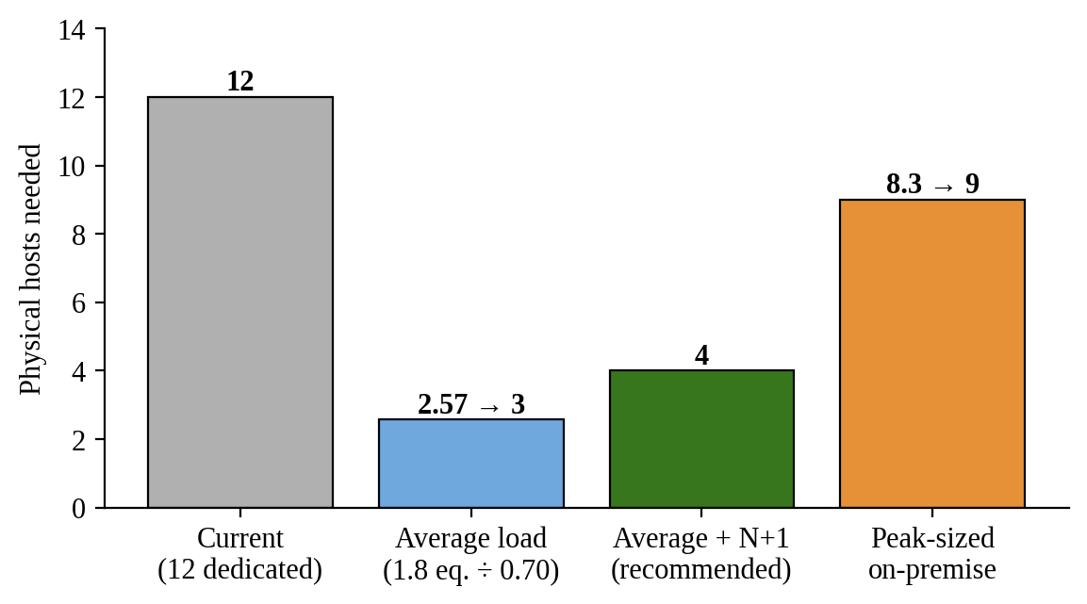
Figure 5: Physical hosts required: current, average-load plan, recommended plan and peak-sized on-premise.
Interpretation. Four hosts are enough for normal operation (a reduction from 12 to 4), but if the university tried to cover its peaks entirely on-premise it would need about 9 hosts, which would sit mostly idle again. This is why the final design (Tasks 8 and 10) keeps a small baseline and uses cloud elasticity for peaks. The figures rely on equal-capacity servers and on peaks being treated simply; real capacity must be validated by measuring CPU, memory, disk I/O and network (not CPU alone) and by a load test.

4.5 Benefits and risks of virtualization
• Live migration: a running VM moves from one host to another with no noticeable downtime (e.g., vMotion, KVM live migration), allowing hardware maintenance without outages.
• Snapshots: a point-in-time copy of a VM's disk and memory allows quick rollback before upgrades or after a failed patch, and simplifies backup.
• Resource over-commitment: allocating more virtual CPUs/memory than physical (e.g., 4 vCPUs per physical core for light workloads) raises utilisation, because VMs rarely peak together.
• Risk – noisy neighbour: one VM consuming CPU or disk I/O can slow others; mitigate with resource limits, reservations and I/O controls.
• Risk – hypervisor failure: a host crash takes down all of its VMs; mitigate with clustering, high-availability restart and the N+1 host.
• Risk – security isolation: hypervisor or side-channel flaws could let one VM reach another; mitigate with patching, network segmentation, hardened hypervisors and placing sensitive systems (e.g., exam and student records) on separate clusters.

TASK 5 – Apply Web Services (4 Marks)

5.1 Web services in cloud and SOA
A web service is a software function that other programs can call over a network using standard web protocols and data formats. In a service-oriented architecture (SOA) each business capability – looking up results, taking a fee payment, searching the library – is published as a service with a clear contract, so any authorised client (a browser, the mobile app, a partner college's system) can reuse it. In the cloud, web services are the connection layer: they let separately hosted and separately scaled components, and external parties, work together without knowing each other's internal technology.

5.2 SOAP, WSDL, UDDI and REST
Table 9: SOAP, WSDL, UDDI and REST compared.
Item | What it is | Notes for the university
SOAP | XML-based messaging protocol with a fixed envelope (header + body); usually over HTTP, can use other transports. Supports WS-Security and WS-ReliableMessaging. | Strict, formal and heavier; suits enterprise integration needing guaranteed delivery and message-level security.
WSDL | XML document that describes a SOAP service: operations, message formats, endpoints. | Allows client code to be generated automatically from the contract.
UDDI | Registry in which services are published and discovered. | Rarely used publicly today; replaced by API catalogues and gateways.
REST | Architectural style using standard HTTP methods (GET, POST, PUT, DELETE) on resources identified by URLs; data usually JSON (or XML). | Light, stateless, cache-friendly and easy for mobile apps; scales well behind a load balancer.

Table 10: SOAP versus REST.
Aspect | SOAP | REST
Message format | XML only | JSON, XML, plain text
Methods | Operations defined in WSDL (POST mostly) | HTTP verbs on resources
Contract | Formal (WSDL) | Informal; OpenAPI/Swagger documents it
Security | WS-Security (message level) + TLS | TLS + OAuth2/JWT tokens
Performance | Heavier payload | Lighter, cacheable
Best for | Formal enterprise/bank integrations, transactions | Mobile/web apps, public APIs, high-volume reads

5.3 Three university functions exposed as web services
Table 11: Web services defined for the university.
# | Function | Endpoint | Method | Style
1 | Result lookup | /api/v1/results/{regNo} | GET | REST (JSON)
2 | Fee payment | https://api.university.edu/soap/FeeService (operation PayFee) | POST (SOAP) | SOAP (XML) with WSDL
3 | Library search | /api/v1/library/books?title={text}&limit={n} | GET | REST (JSON)

Service 1 – Result lookup (REST)
Request:
GET /api/v1/results/192521171 HTTP/1.1
Host: api.university.edu
Accept: application/json
Authorization: Bearer <token>

Response: 200 OK
{
"regNo": "192521171",
"name": "Mohamed Saif A",
"semester": 3,
"gpa": 8.7,
"courses": { "CSA15": "A", "CSA12": "A", "CSA14": "B+" }
}

Response if not found: 404 Not Found
{ "error": "Student not found", "regNo": "999999999" }

Service 2 – Fee payment (SOAP)
Request:
POST /soap/FeeService HTTP/1.1
Content-Type: text/xml; charset=utf-8
SOAPAction: "urn:university:PayFee"

<soapenv:Envelope xmlns:soapenv="http://schemas.xmlsoap.org/soap/envelope/"
xmlns:fee="urn:university:fees">
<soapenv:Header>
<fee:Security><fee:Token>abc123</fee:Token></fee:Security>
</soapenv:Header>
<soapenv:Body>
<fee:PayFee>
<fee:regNo>192521171</fee:regNo>
<fee:term>2026-ODD</fee:term>
<fee:amount>45000.00</fee:amount>
<fee:paymentRef>TXN-20261031-0042</fee:paymentRef>
</fee:PayFee>
</soapenv:Body>
</soapenv:Envelope>

Response:
<soapenv:Envelope xmlns:soapenv="http://schemas.xmlsoap.org/soap/envelope/"
xmlns:fee="urn:university:fees">
<soapenv:Body>
<fee:PayFeeResponse>
<fee:status>SUCCESS</fee:status>
<fee:receiptNo>RCPT-882001</fee:receiptNo>
</fee:PayFeeResponse>
</soapenv:Body>
</soapenv:Envelope>

Service 3 – Library search (REST)
Request:
GET /api/v1/library/books?title=cloud&limit=2 HTTP/1.1
Accept: application/json

Response: 200 OK
{
"count": 2,
"books": [
{ "isbn": "9780000000011", "title": "Cloud Computing Fundamentals", "available": true },
{ "isbn": "9780000000028", "title": "Big Data Analytics", "available": false }
]
}

(The request/response bodies above are sample formats defined for this design. The result-lookup response is exactly what the proof-of-concept in Task 9 returns.)

5.4 SOAP or REST for each function
Table 12: Justified choice of SOAP or REST.
Function | Choice | Justification
Result lookup | REST | Read-only, very high volume at result publication; JSON is small and cacheable, so a CDN and cache can absorb the peak; easy for the mobile app.
Fee payment | SOAP | Financial transaction with a formal contract (WSDL), message-level security (WS-Security) and reliable-messaging needs; banks and payment back-ends commonly require it. The mobile app and colleges will still call a REST façade at the API gateway, which converts requests into the SOAP call.
Library search | REST | Simple, stateless searches; light payloads; benefits from caching; public and mobile friendly.

TASK 6 – Analyse the Service Models: IaaS, PaaS and SaaS (5 Marks)

6.1 Definitions and layer-wise responsibility
• IaaS (Infrastructure as a Service): the provider supplies virtualised servers, storage and networking; the customer installs and manages the operating system, middleware, runtime, data and applications.
• PaaS (Platform as a Service): the provider also manages the operating system, middleware and runtime; the customer deploys and manages only the application and its data.
• SaaS (Software as a Service): the provider delivers a complete application; the customer only configures it and manages users and the content it holds.
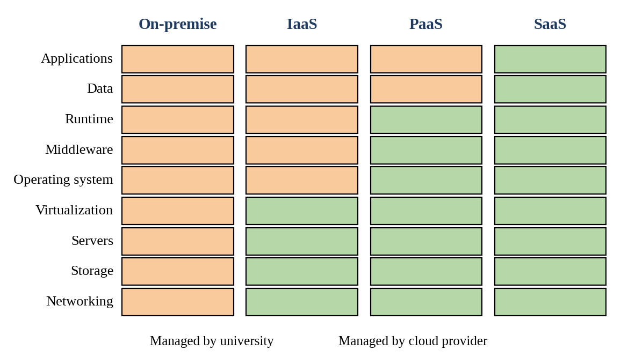
Figure 6: Who manages each layer in on-premise, IaaS, PaaS and SaaS models.

6.2 Categorisation of the five applications
Table 13: Mapping of university applications to service models.
Application | Service model | Provider example
Student Information System (SIS) | PaaS (managed database + application platform) | Azure App Service / Google App Engine / AWS Elastic Beanstalk
Learning Management System (LMS) | SaaS (hosted/managed LMS) | Moodle hosting, Google Classroom, Canvas
Library system | SaaS (cloud library management) | Hosted Koha or similar library SaaS
Exam Portal | IaaS (auto-scaling VMs/containers) | AWS EC2, Azure Virtual Machines, Google Compute Engine
Email | SaaS | Google Workspace for Education, Microsoft 365 Education

Reasoning behind each decision
• SIS → PaaS. It is a custom application with a database; the university wants to write and maintain code, not operate servers. PaaS removes OS/runtime patching and gives managed database backups and scaling. The monolith must first be adapted (stateless sessions, externalised configuration), so it initially runs as a lift-and-shift on IaaS and is later refactored to PaaS (see Task 10 roadmap).
• LMS → SaaS. A learning management system is a commodity function; running it ourselves adds little value. A hosted LMS scales with class timetables, is updated by the vendor and removes server administration. The limitation is less customisation, which is acceptable for a standard LMS.
• Library → SaaS. A low-volume standard application with little unique logic. SaaS is cheapest to operate and keeps the IT team free for core systems; data export must be guaranteed in the contract to avoid lock-in.
• Exam Portal → IaaS. It is the most bursty workload and carries special requirements (proctoring components, strict timing, custom network rules, specific software versions). IaaS gives full control of the stack and fast horizontal scaling through auto-scaling groups, which PaaS or SaaS might restrict. It is a candidate for later containerisation/PaaS.
• Email → SaaS. Email is a well-served commodity with high security and spam-filtering demands; hosted education suites offer large mailboxes, spam/phishing protection and high availability at low or no per-user cost, replacing the legacy server.

6.3 Comparison of the models
Table 14: Service models compared on five criteria.
Criterion | IaaS | PaaS | SaaS
Control | Highest (OS and up) | Medium (application and data) | Lowest (configuration only)
Cost | Pay for resources used; need staff to manage | Moderate; fewer staff needed | Per-user/subscription; lowest admin cost
Scalability | High but must be configured (auto-scaling) | High; platform scales app automatically | Handled entirely by vendor (within plan limits)
Maintenance effort | High (patching OS, middleware) | Low–medium (application only) | Minimal
Vendor lock-in | Low–medium (VMs are portable) | Medium–high (platform-specific services) | Highest (data and workflows tied to the product)

Provider examples: IaaS – Amazon EC2 (AWS); PaaS – Google App Engine / Azure App Service; SaaS – Google Workspace / Microsoft 365.

TASK 7 – Examine XaaS (3 Marks)

7.1 What XaaS is
XaaS (Anything/Everything as a Service) is the extension of the service idea beyond IaaS, PaaS and SaaS: any IT function – desktops, databases, security, backup, functions, backend – can be bought as a subscription or pay-per-use service instead of being built and run in-house. The benefits are faster adoption, specialised expertise supplied by the provider, and costs that follow use.

7.2 Variants
Table 15: XaaS variants and their relevance.
Variant | Description | Possible use at the university
DaaS – Desktop as a Service | Virtual desktops streamed from the cloud. | Computer labs and remote students use virtual desktops with licensed software, reducing the need to refresh lab PCs.
MBaaS/BaaS – (Mobile) Backend as a Service | Ready-made back-end: authentication, push notifications, storage for apps. | Speeds up the Day-4 mobile app (login, notifications, file storage).
FaaS – Function as a Service (serverless) | Small functions run on events and are billed per execution. | Result-publication notifications, PDF generation, fee-payment webhooks.
DBaaS – Database as a Service | Managed database with automatic backup, patching, replication and scaling. | Hosts the SIS and fee data with multi-zone failover.
SECaaS – Security as a Service | Cloud-delivered security: identity, web-application firewall, anti-DDoS, monitoring. | Protects public APIs and student accounts.
DRaaS – Disaster Recovery as a Service | Replication and recovery of systems in a provider's other site or region. | Gives the university the DR site it lacks.

7.3 Two selected offerings – DBaaS and DRaaS
• DBaaS. The student, fee and result data are the university's most valuable and most heavily used asset. A managed database provides automated backups, point-in-time recovery, patching, read replicas and multi-AZ standby, which would otherwise need specialist database administrators. It directly improves availability and manageability and scales reads during result publication. It also removes the single point of failure of one database server.
• DRaaS. The university has no DR site; building a second data centre would roughly double hardware cost. DRaaS replicates data and keeps a minimal environment ready in another region, billed mainly for storage until a disaster, so cost is small compared with the risk it removes. It supports the targets of RPO (data-loss window) ≈ 15 minutes and RTO (recovery time) ≈ 1 hour used later.

7.4 Risks of over-reliance on many “as-a-Service” providers
• Lock-in and integration complexity: each provider has its own formats and APIs; moving later is costly.
• Cascading outages: the system is only as available as the weakest provider; a single provider failure can stop the whole workflow.
• Security and compliance: data passes through many parties, increasing the attack surface and complicating data-protection duties.
• Cost sprawl: many small subscriptions are hard to track and may exceed budget.
• Reduced in-house skill and control over performance, upgrades and roadmap; business risk if a provider closes or changes price.
• Mitigation: limit the number of providers; use open standards and exportable data formats; review SLAs and exit clauses; central billing alerts; keep a tested exit plan.

TASK 8 – Design the Cloud Solution Architecture (5 Marks)

8.1 Architecture diagram
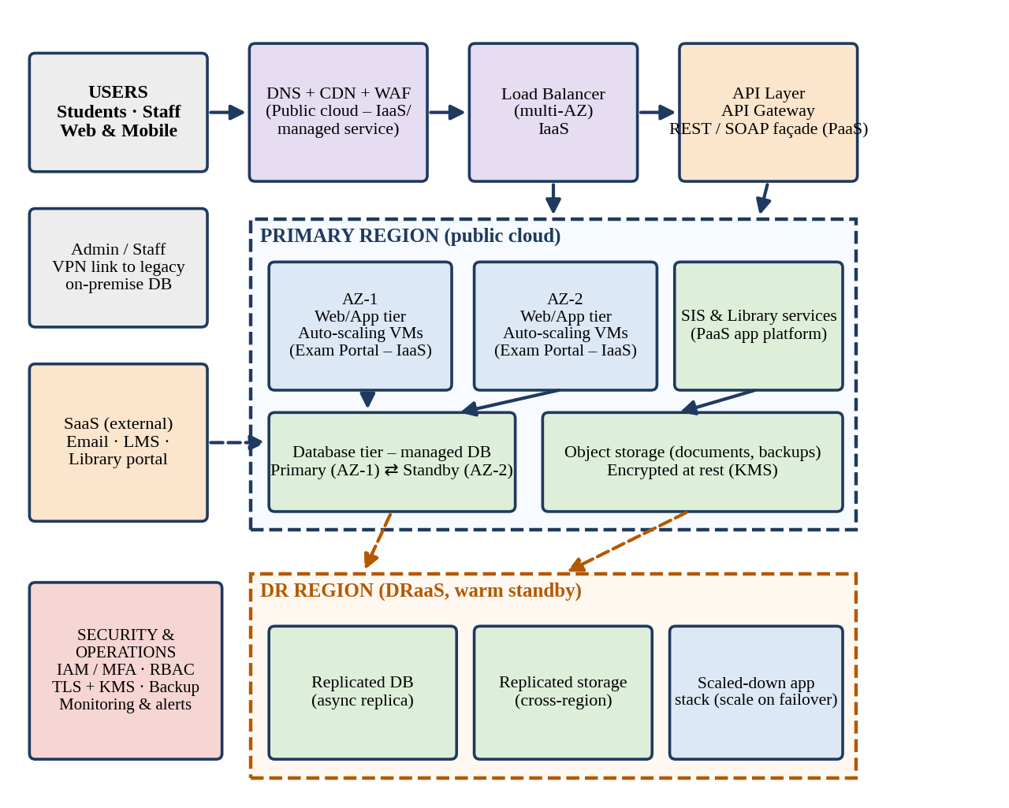
Figure 7: Proposed cloud architecture for the university (users, load balancer, API layer, application tier, database tier, storage and DR region).

8.2 Components, deployment models and service models
Table 16: Components, deployment models and service models.
Component | Deployment model | Service model | Justification
Users (students, staff, colleges) | – | – | Reach services through browsers and the mobile app over HTTPS.
DNS + CDN + WAF | Public | Managed service (SaaS-like/XaaS) | Caches static and read-heavy content close to users, filters attacks and absorbs peak traffic before it reaches the servers.
Load balancer (multi-AZ) | Public | IaaS | Spreads requests across instances in two zones and removes unhealthy ones – needed for availability.
API gateway / API layer | Public | PaaS | Single secured entry point for REST/SOAP services: authentication, throttling, logging and versioning.
Web/application tier (Exam Portal) | Public | IaaS (auto-scaling VMs/containers) | Full control for the bursty exam workload; stateless instances in two zones scale out within minutes.
SIS and library services | Public | PaaS | Runs application code without OS management; scales automatically and is easy to deploy.
Database tier | Public (legacy master DB temporarily on-premise via VPN → hybrid) | DBaaS (PaaS) | Multi-AZ primary/standby, automatic backup and patching; reduces administration.
Object storage | Public | IaaS/PaaS storage | Durable, cheap storage for documents, answer scripts, logs and backups; encrypted at rest.
Email, LMS, library portal | Public | SaaS | Commodity applications bought as services; no servers to manage.
DR region | Public (second region) | DRaaS | Replicated database and storage; warm standby that can be scaled up on failover.
Security and operations | – | SECaaS + IAM | Identity, MFA, role-based access, encryption keys, monitoring and alerts.

8.3 Elasticity: handling admissions and exam peaks
• Scale-out rules: add instances when average CPU stays above ~60% for 3 minutes, or when requests per instance or queue length exceeds a threshold; remove them when CPU stays below ~30% for 10 minutes (scale-in cool-down).
• Scheduled scaling: because admissions, result days and exam dates are known, capacity is raised in advance on a schedule so there is no start-up delay.
• Minimum and maximum limits: minimum of 2 instances (one per zone) for availability; a maximum cap to protect the budget.
• Stateless design and caching: sessions kept in a shared cache so any instance can serve a user; read-heavy results are cached and delivered through the CDN.
• Database scaling: read replicas for result lookups; connection pooling and queueing to protect the primary during bursts.

8.4 Security and availability measures
• Access control: identity and access management with least privilege, role-based access (student, staff, administrator), multi-factor authentication for staff and administrators.
• Encryption: TLS for data in transit; encryption at rest with provider-managed or customer-managed keys.
• Network security: private subnets for application and database tiers, security groups/firewalls, WAF and DDoS protection at the edge, VPN for the on-premise link.
• Backup: automated daily backups plus point-in-time recovery for the database; backups copied to the DR region; periodic restore tests.
• Multi-zone deployment: application and database spread across two availability zones; automatic failover.
• Disaster recovery: warm standby in a second region; target RPO ≈ 15 min and RTO ≈ 1 h; DR drill at least twice a year.
• Monitoring and audit: central logs, alarms on errors/latency/cost, and audit trails for student-record access.

TASK 9 – Hands-on Implementation and Documentation (4 Marks)

9.1 Objective and environment
A small proof-of-concept (PoC) of the result-lookup REST service (Service 1 of Task 5) was built as a Python Flask application, packaged for a container with a Dockerfile, and tested with curl. This is the application tier that would run in the container platform / PaaS in the final design.
Table 17: Environment details for the proof-of-concept.
Item | Details
Language / framework | Python 3 with Flask 3.1 (REST API returning JSON)
Container definition | Dockerfile based on python:3.12-slim; gunicorn as production web server; port 5000
Where it was executed | Python/Flask run locally in the working environment; test client: curl
Cloud/PaaS target | Any container PaaS on a free tier (Google Cloud Run, Azure App Service, Render) – steps in 9.4
Test data | Two sample student records held in memory (register number 192521171 and 192521002)

9.2 Source code
app.py
from flask import Flask, jsonify

app = Flask(__name__)

RESULTS = {
"192521171": {"name": "Mohamed Saif A", "semester": 3, "gpa": 8.7,
"courses": {"CSA15": "A", "CSA12": "A", "CSA14": "B+"}},
"192521002": {"name": "Sample Student", "semester": 3, "gpa": 7.9,
"courses": {"CSA15": "B+", "CSA12": "B", "CSA14": "B"}},
}

@app.route("/api/v1/health")
def health():
return jsonify(status="UP", service="university-results-api")

@app.route("/api/v1/results/<reg_no>")
def get_result(reg_no):
rec = RESULTS.get(reg_no)
if rec is None:
return jsonify(error="Student not found", regNo=reg_no), 404
return jsonify(regNo=reg_no, **rec)

if __name__ == "__main__":
app.run(host="0.0.0.0", port=5000)

requirements.txt and Dockerfile
# requirements.txt
flask==3.1.0
gunicorn==22.0.0

# Dockerfile
FROM python:3.12-slim
WORKDIR /app
COPY requirements.txt .
RUN pip install --no-cache-dir -r requirements.txt
COPY app.py .
EXPOSE 5000
CMD ["gunicorn", "-b", "0.0.0.0:5000", "app:app"]

9.3 Execution evidence (actual run)
The commands below were run against the application above. Figure 8 shows the Flask server output and Figure 9 the actual curl output (a successful query returning HTTP 200 with JSON, a health check, and a failure case returning HTTP 404). The images are rendered from the real captured terminal text.
$ pip install flask gunicorn
$ python3 app.py # start the service on port 5000
$ curl -i http://localhost:5000/api/v1/health
$ curl -i http://localhost:5000/api/v1/results/192521171 # functional: 200
$ curl -i http://localhost:5000/api/v1/results/999999999 # failure: 404

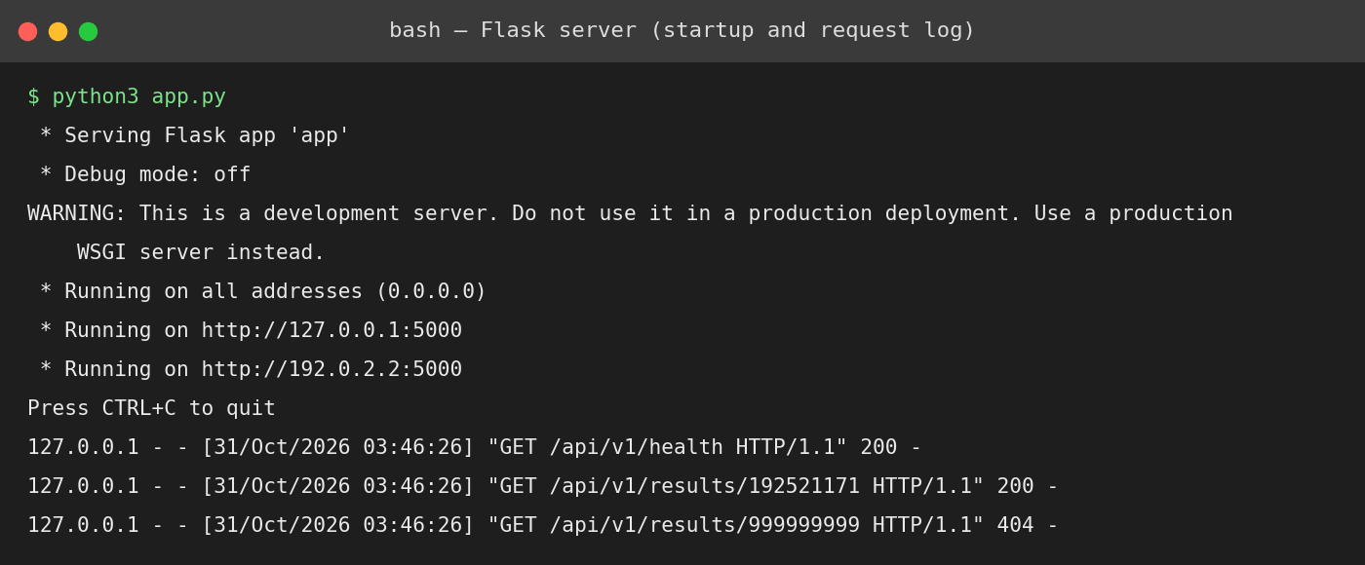
Figure 8: Flask service started and handling requests (actual output).
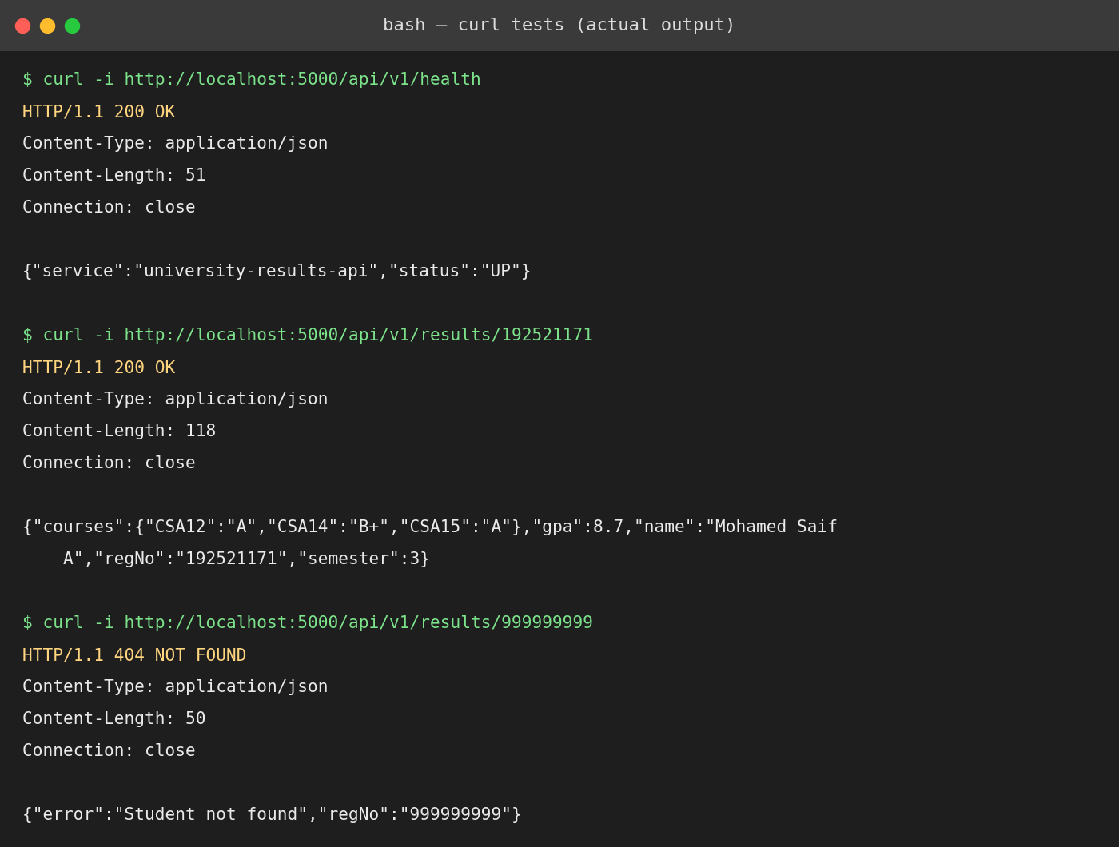
Figure 9: curl tests: health check (200), valid result lookup (200 JSON) and unknown student (404) – actual output.
Table 18: Test results of the proof-of-concept.
Test | Request | Expected | Observed
Health check | GET /api/v1/health | 200 OK, status UP | 200 OK, {"service":"university-results-api","status":"UP"}
Functional | GET /api/v1/results/192521171 | 200 OK with student JSON | 200 OK, JSON with name, semester 3, gpa 8.7 and three course grades
Failure case | GET /api/v1/results/999999999 | 404 Not Found with error JSON | 404 NOT FOUND, {"error":"Student not found","regNo":"999999999"}

9.4 Container and PaaS deployment steps (to reproduce)
Docker and a cloud account were not available in the environment where the code was executed, so the container and cloud steps below are the documented procedure and have not been run here. They should be executed on a machine with Docker and a free-tier account, and the screenshots inserted in the boxes below.
# A. Build and run the container locally
docker build -t university-results-api .
docker run -d -p 5000:5000 --name results-api university-results-api
docker ps
curl -i http://localhost:5000/api/v1/results/192521171
curl -i http://localhost:5000/api/v1/results/999999999

# B. Deploy to a PaaS (example: Google Cloud Run, free tier)
gcloud auth login
gcloud config set project <PROJECT_ID>
gcloud run deploy results-api --source . --region asia-south1 --allow-unauthenticated
# note the service URL printed, then test it:
curl -i https://<SERVICE_URL>/api/v1/results/192521171

# C. Alternative SaaS/PaaS component: static site or serverless function
# (e.g., host a result-search HTML page on a static-site service
# and call the API above with fetch())

[Insert your screenshot here: docker build / docker run completed, and “docker ps” showing the running container “results-api”]

[Insert your screenshot here: cloud console / PaaS dashboard showing the deployed service and its public URL]

[Insert your screenshot here: curl or Postman test against the public URL (HTTP 200 and HTTP 404 cases)]

9.5 Issues and observations
• Flask's built-in server is for development only; the Dockerfile therefore starts the app with gunicorn for production use.
• Flask returns JSON keys in alphabetical order (visible in the output); this does not affect clients, which read by key name.
• Data is held in memory for the PoC. In the real system it comes from the managed database (DBaaS) and the API is protected by the API gateway with token authentication and rate limiting.
• The container and PaaS deployment steps have not yet been executed; they are the remaining work needed to complete full evidence for this task.

TASK 10 – Evaluate and Recommend the Final Solution (7 Marks)

10.1 Comparison of the three options
Option A: refresh and virtualize on-premise (sized for peak, with a DR site). Option B: IaaS-based (lift-and-shift to cloud VMs). Option C: PaaS/SaaS-based (managed platform and hosted applications).
Table 19: Comparison of on-premise, IaaS and PaaS/SaaS options.
Criterion | A – On-premise | B – IaaS | C – PaaS/SaaS
Cost model | High CapEx (hardware, DR site) plus fixed OpEx | No CapEx; OpEx pay-per-use; one-time migration | No CapEx; OpEx subscription/usage; higher one-time re-engineering
Scalability | Fixed; needs ~9 hosts to cover peaks, then idle | High, auto-scaling; configured by us | Highest, mostly automatic
Availability | Single data centre; DR site must be built and run | Multi-zone and multi-region possible; we design it | Provider-managed redundancy; SLA-backed
Security | Full control; we carry all responsibility | Shared responsibility; we secure OS and above | Provider secures most layers; we manage data and access
Effort / skills | Highest (hardware, OS, DR) | Medium (OS, patching, scaling rules) | Lowest operations; needs application changes and vendor management

10.2 Three-year cost comparison (assumptions stated)
Table 20: Cost assumptions.
Assumption | Value
Currency | ₹ lakh (₹100,000); costs are estimates, to be validated by provider quotations
Reserved cloud VM (4 vCPU, 16 GB) | ₹8 per hour ≈ ₹70,080 per year; on-demand ₹14 per hour
Peak period | 8 weeks per year (3 admissions, 2 results, 3 exams) = 1,344 hours
Administrator cost | ₹8 lakh per year each
Option A | 9 hosts × ₹8 lakh = 72; storage and network 20; DR site 45 → CapEx 137. Annual: power/cooling/space 14; 4 administrators 32; AMC and licences 16 → 62
Option B | Migration 20 (planning, data move, training). Annual: 24 reserved VMs 16.8; burst 12 VMs × 1,344 h × ₹14 = 2.3; storage/backup/DR replication 10; network 5; monitoring/security 4 → 38.1; 3 administrators 24 → 62.1
Option C | Re-engineering and migration 40. Annual: email 1, LMS 8, library 2, PaaS for SIS + Exam 14, managed DB 7, DR/backup 4, monitoring/security 3 → 39; 2 administrators 16 → 55

Table 21: Three-year total cost of ownership.
Item (₹ lakh) | A – On-premise | B – IaaS | C – PaaS/SaaS
One-time / CapEx | 137 | 20 | 40
Annual OpEx | 62 | 62.1 | 55
3-year OpEx | 186 | 186.3 | 165
3-year total | 323 | 206 | 205

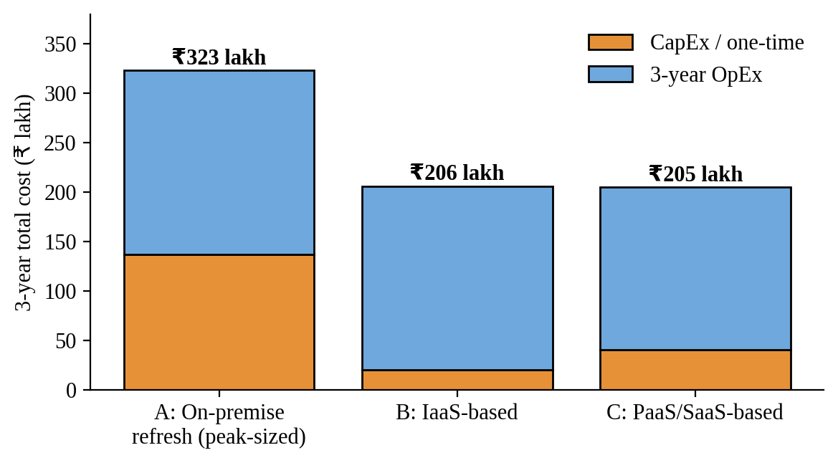
Figure 10: Three-year cost comparison of the three options (₹ lakh).
Interpretation. Staying on-premise is clearly the most expensive (about ₹323 lakh), mainly because it must buy hardware for peak load and build a DR site. Options B and C cost almost the same over three years (about ₹205–206 lakh, roughly 36% below A). C is cheaper to run each year (₹55 vs ₹62 lakh) and needs fewer administrators, but demands more re-engineering and carries more vendor dependence; B is faster and less risky to start. Cost alone therefore does not separate B and C; the decision is made on risk and effort below.

10.3 Main risks and mitigation
Table 22: Risk register with mitigation.
Risk | Impact | Mitigation
Vendor lock-in | Hard and costly to change provider | Use containers, standard databases and open APIs; export-ready data formats; exit clause and tested exit plan; avoid proprietary services for core logic.
Data privacy and compliance | Exposure of student and fee data; legal penalties | Choose a region within India; encryption at rest/in transit; role-based access; audit logs; data-processing agreement with the provider; follow the Digital Personal Data Protection Act.
Downtime | Lost admissions, exams or results | Multi-zone deployment; DB standby; warm DR region; SLA ≥ 99.95%; health checks and alerts; DR drills.
Skills gap | Mis-configuration, high bills | Training and certification for IT staff; pilot project; managed-service partner for the first year; cost alerts and budgets.
Migration failure | Data loss or long outage | Phased migration; backups and rollback plans; parallel run; testing with real load.

10.4 Final recommendation
Recommended solution: a phased hybrid cloud that combines SaaS for commodity applications, PaaS/DBaaS for the SIS and IaaS for the Exam Portal, with DRaaS in a second region. This is the architecture shown in Figure 7. It is supported by the earlier tasks: Task 4 showed that peaks cannot be economically covered by owned hardware; Task 6 showed that email, LMS and library are commodity SaaS candidates, SIS suits PaaS, and the Exam Portal needs the control and elasticity of IaaS; Task 7 selected DBaaS and DRaaS to meet availability; and the cost analysis shows a saving of about ₹115–118 lakh (≈36%) against Option A over three years, with spending that follows use.
Provider selection. The provider is deliberately not named on popularity. It will be chosen from a shortlist (for example the three major global public clouds and a local provider) using these criteria: a region in India (data residency and latency to the 4 campuses); published SLAs of at least 99.95% for compute and database; education pricing and committed-use discounts; availability of managed database and DR services; exportable data and open standards; quality of support; and the result of a short pilot using the Task 9 PoC and a load test.

10.5 Migration roadmap
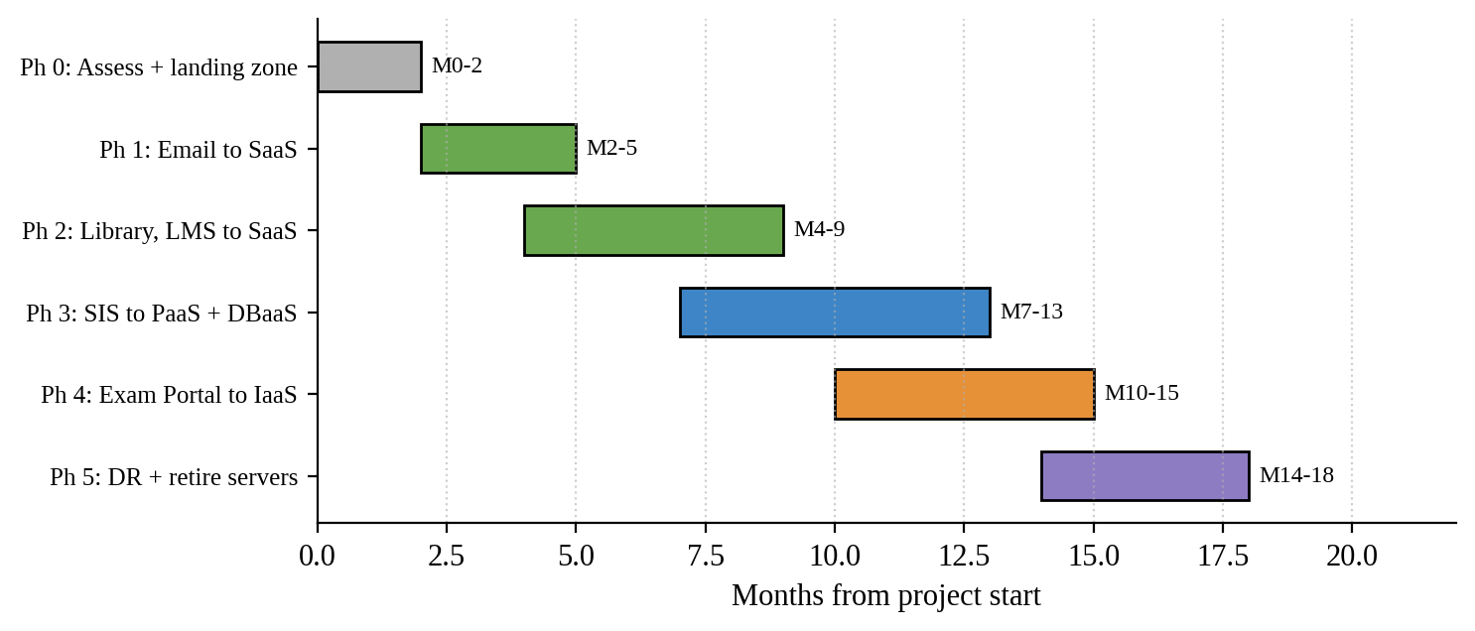
Figure 11: Phased migration roadmap (months).
Table 23: Roadmap: order of migration and reason.
Phase | Months | What moves | Why in this order
0 | 0–2 | Assessment, landing zone, identity/MFA, network and VPN, monitoring, cost controls | Foundation and security must exist before any application moves.
1 | 2–5 | Email → SaaS (first application) | Commodity service with no custom code, high user-visible benefit, low risk and easily reversible; teaches the team the process.
2 | 4–9 | Library → SaaS; LMS → hosted/managed | Standard applications with modest data; reduce server count quickly.
3 | 7–13 | SIS → PaaS with DBaaS (initially lift-and-shift to IaaS, then refactor) | Core system with the most data; moved after the team has experience; needs API creation and thorough testing.
4 | 10–15 | Exam Portal → IaaS auto-scaling (containers) | Must be ready and load-tested before the next exam cycle; scheduled so migration avoids exam weeks.
5 | 14–18 | DR region, DR drill, decommission old servers | Retire the 12 old servers once everything is stable and DR is proven.

TASK 11 – Re-evaluate and Adapt the Design (Day-4 Design Challenge) (8 Marks)
Changed requirement: mobile app and open student-record and fee-payment services to 40 affiliated colleges; load 10× the current peak; availability 99.9%; limited operating budget. Decision: MODIFY the original design (a substantial modification, not a full redesign), as justified below.

11.1 Impact analysis (2 marks)
Table 24: Original assumptions affected by the Day-4 change.
Item | Original assumption | Changed condition
Users | ~27,000 users on 4 campuses | Students and staff plus users of 40 colleges and a mobile app (users grow several-fold; usage is spread across devices and time)
Load | Peak ≈ 3,000 concurrent users (assumed ≈ 11% of users) | 10 × peak ≈ 30,000 concurrent users
Availability | Not stated; single region, no formal target (best effort) | 99.9% → at most 8.76 hours of downtime per year (0.001 × 8,760 h)
Cost | Budget for one university | Limited operating budget; costs may be shared with colleges
Access | Internal users and a few staff systems | External organisations through APIs; 24×7 mobile traffic

• What has changed: from an internal system for one institution to a shared, internet-facing, multi-organisation platform with a formal availability target and ten times the peak.
• Web services and APIs become critical: the mobile app and the 40 colleges can only use student-record and fee functions through well-defined, secured, versioned APIs. The API layer is now the product's front door; its availability, throttling and security determine the whole service. It must also protect back-end systems from heavy traffic and from misbehaving clients.
• Multi-tenant access: each college must see only its own students; isolation must be enforced at the API (tenant identity in OAuth2/JWT tokens), the application (tenant-aware authorisation) and the data layer (tenant_id with row-level security, separate encryption keys or schemas for sensitive data). A fault or attack on one college must not affect others – so per-tenant rate limits and quotas are required. Fee payment adds payment-security duties: card data should never be stored by the university but handled by a certified payment gateway.

11.2 Evaluation of the original design (2 marks)
(a) Can the service-model mix and virtualization plan handle 10×? Partly. The service models themselves (SaaS for email/LMS/library, PaaS for SIS, IaaS for the Exam Portal) remain sensible. But sizing shows the original application tier would be heavy. Assuming one 4-vCPU node serves about 300 concurrent users at ≤70% CPU (to be confirmed by load testing):
Today's peak : 3,000 / 300 = 10 nodes
10x peak : 30,000 / 300 = 100 nodes (no caching)

100 nodes is possible with auto-scaling, but the single large database (vertically scaled) and the single-zone application tier become bottlenecks and failure points.
(b) Are auto-scaling and a single region enough for 99.9%? No. Using typical published availability figures as indicative assumptions (to be replaced by the chosen provider's SLA):
Original (single zone): load balancer 99.99% x app 99.5% x database 99.5%
= 0.9999 x 0.995 x 0.995 = 0.98993 -> about 98.99%
Downtime = (1 - 0.98993) x 8,760 h = about 88 hours/year (target: 8.76 h)

Auto-scaling replaces failed instances but cannot cover a zone outage or a
database failure, and a single region has no protection against a regional
event.

(c) Is the cost acceptable? Scaling the original design to 10× costs about ₹78 lakh per year (Table 26) but still misses the availability target; adding the missing high-availability pieces raises it further, and it wastes money because every request, even repeated result lookups, reaches the application tier.
(d) Would another service model or XaaS give better results? Yes. A CDN/cache and API gateway (managed services), container orchestration for the application tier, serverless functions (FaaS) for bursty event work such as payment webhooks and notifications, an MBaaS-style backend for the mobile app, and DBaaS with read replicas improve both cost and availability.

11.3 Adaptation – decision: MODIFY (2 marks)
Why modify rather than retain or redesign? The core decisions – hybrid cloud, SaaS for commodity applications, PaaS/DBaaS for the SIS, DRaaS, security model – are still valid, so a redesign from scratch would waste the investment and delay delivery. Retaining the design unchanged fails the availability target (≈ 98.99%) and cannot provide tenant isolation or an external API platform. Therefore the architecture is modified in the areas below.
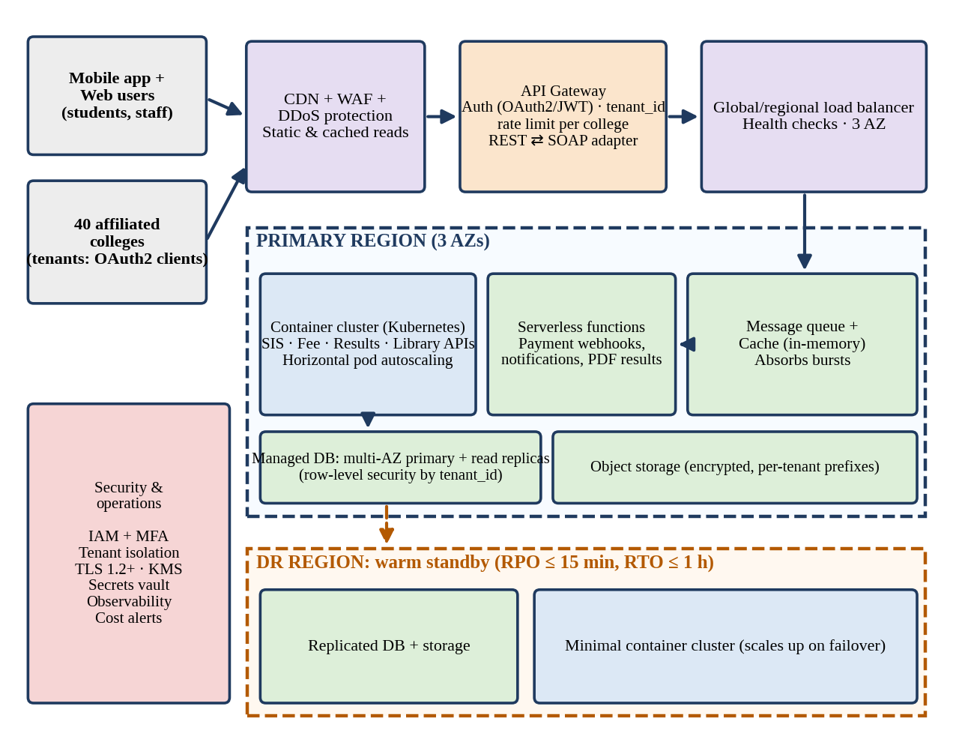
Figure 12: Revised cloud architecture for the Day-4 requirements (API gateway, container cluster, serverless, caching, multi-AZ database, DR region).
Table 25: What changed in the revised design.
Area | Original design | Revised design
Entry layer | Load balancer + API layer | CDN + WAF + DDoS protection, then API gateway with OAuth2/JWT, tenant identity, per-college rate limits and REST ⇄ SOAP adapter
Virtualization approach | VMs and auto-scaling groups for the exam tier | Container orchestration (Kubernetes) for all stateless services over three availability zones; VMs remain for stateful legacy components
Service model mix | SaaS + PaaS + IaaS | Adds FaaS (serverless) for bursts, MBaaS-style mobile backend, managed cache and message queue, and DBaaS with read replicas
Data tier | Primary and standby in two zones | Multi-AZ managed database with read replicas; tenant_id row-level security; per-tenant encryption prefixes in object storage
Availability | Two zones; DR region warm standby | Three zones; automatic failover; warm DR region with RPO ≤ 15 min and RTO ≤ 1 h; health checks and automated failover tests
Cost control | Auto-scaling cap | Caching to cut app load by ~60%; scheduled scaling; reserved capacity for baseline; per-tenant usage metering

11.4 Evidence-based defence (2 marks)

Capacity calculation
Peak concurrent users = 30,000
Share absorbed by CDN + cache = 60% (assumed: static content, results)
Load reaching the application tier = 30,000 x 0.40 = 12,000 users
Nodes needed (300 users per node) = 12,000 / 300 = 40 nodes
Survive loss of one of 3 zones = 20 nodes per zone x 3 = 60 nodes
(after losing a zone, 40 remain = needed)
Baseline outside peak weeks = 10 reserved nodes

Availability calculation (revised, three zones)
API gateway 99.99% x Load balancer 99.99% x App (multi-AZ) 99.99%
x Database (multi-AZ) 99.95%
= 0.9999 x 0.9999 x 0.9999 x 0.9995 = 0.99920 -> about 99.92%
Downtime = (1 - 0.99920) x 8,760 h = about 7.0 hours/year (allowed: 8.76)

The margin is small, so the design adds a CDN (serves cached reads even if
the origin has a fault), a DR region and an SLA/credit clause. Figures use
indicative SLAs; check them against the chosen provider's SLA and a failover
test.

Cost comparison
Table 26: Annual cost of the original and revised designs at 10× load.
Cost item (₹ lakh per year) | Original design at 10× | Revised design
Compute – baseline (10 reserved nodes × ₹70,080) | 7.0 | 7.0
Compute – peak burst on demand (8 weeks × ₹14/h)  90 nodes vs 50 extra nodes | 16.9 | 9.4
Database | 14.4 (single large instance) | 22.0 (multi-AZ + replicas)
CDN, cache, API gateway, queue | 0 | 9.0
Data transfer / egress | 9.0 | 5.0
Disaster recovery | 4.0 (cold backups) | 10.0 (warm standby)
Security and monitoring | 3.0 | 6.0
Operations staff (3 administrators) | 24.0 | 24.0
Total per year | 78.3 | 92.4
Meets 99.9% target? | No (≈ 98.99%) | Yes (≈ 99.92%)

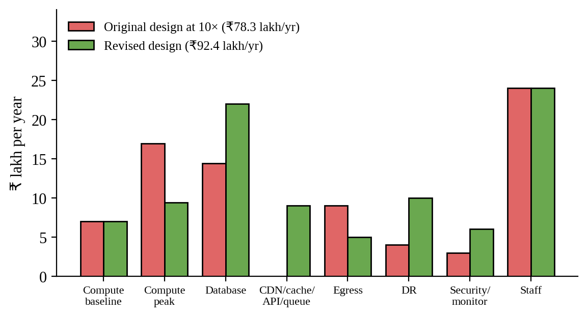
Figure 13: Annual cost by item: original design at 10× versus revised design.
Reading the numbers. The revised design costs about ₹14 lakh per year (≈ 18%) more than the original design scaled to 10×, but it is the only one that meets 99.9%. Compared with today's IaaS run-rate of about ₹62 lakh (Table 21), 10× peak load costs ₹92.4 lakh, an increase of roughly 49%, not 900%. Cost per peak concurrent user falls from about ₹2,067 per year (₹62 lakh ÷ 3,000) to about ₹308 (₹92.4 lakh ÷ 30,000), a reduction of about 85%. If the university charges a service fee to the 40 colleges, a recovery of only ₹1.5 lakh per college per year (₹60 lakh) would cover about 65% of the running cost, helping the limited budget.

Security and multi-tenancy
• Identity: every college is a separate OAuth2 client; tokens carry the tenant ID; staff accounts protected by MFA.
• Isolation: shared database with tenant_id and row-level security for most data; separate schema or database and separate keys for the most sensitive data if required by colleges; per-tenant prefixes and encryption keys in object storage.
• Protection: WAF, rate limiting and quotas per tenant, input validation, audit logging of every access to student records, and regular penetration testing.
• Payment: card details handled only by a certified payment gateway; the university stores only transaction references.

Trade-offs
Table 27: Trade-offs of the final decision.
Trade-off | Consequence | How it is managed
Vendor lock-in | Managed services (API gateway, serverless, DBaaS) tie the system to a provider | Keep core logic in portable containers; standard SQL and OpenAPI; documented exit plan
Complexity | Kubernetes, gateway and multi-tenancy need new skills | Managed Kubernetes service; training; infrastructure as code; a managed-service partner at the start
Migration effort | Services must be split into stateless APIs and containers | Do it in the phases of the roadmap; start with result lookup and fee payment services
Cost versus availability | The 99.9% target adds about ₹14 lakh a year | Cache, scheduled scaling and reserved baseline; fee recovery from colleges
Estimates | All numbers are based on assumptions | Load-test and pilot before committing; review monthly with budget alerts

Conclusion
The Day-4 requirements do not make the original cloud strategy wrong, but they do expose the weaknesses of a single-zone, VM-centred design. By modifying it – an API gateway with tenant security, containers across three zones, caching and serverless for bursts, DBaaS with replicas, and a warm DR region – the university can support 10× load and 99.9% availability at about ₹92 lakh per year, with every figure traceable to the assumptions above and open to validation by load testing and a provider SLA review.

